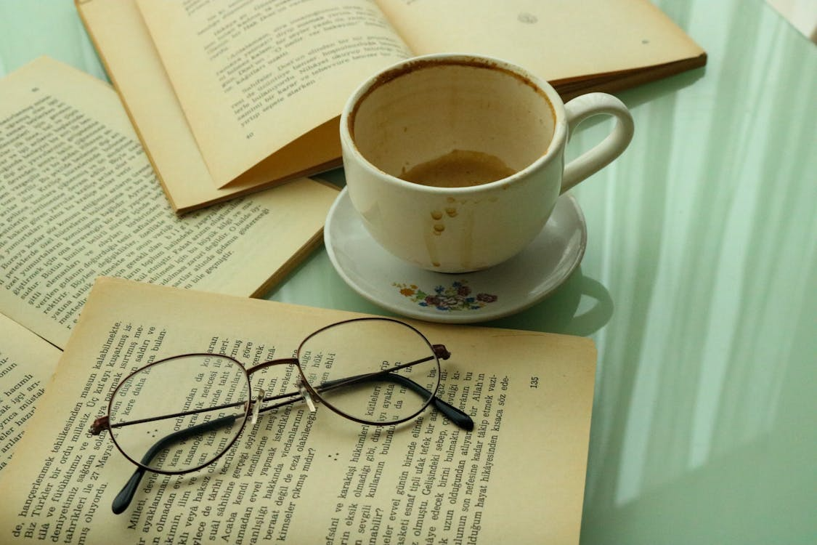

Photo by Feyza Daştan: <https://www.pexels.com/photo/a-ceramic-cup-and-saucer-near-the-open-books-with-eyeglasses-10554033/>

I chose to recreate all the objects in the original image because there aren’t that many, and the books could use the same drawing function. The most complex objects, the glasses and the coffee cup, are the focal point of the image, so they're nearest to the center of my scene. I sacrificed some accuracy with a few of the textures I used because I couldn’t find ones that looked as much like the original as I wanted them to. One of the biggest development decisions I made was how I separated the objects into their own draw functions—the details of which I’ll explain in the latter “custom functions” paragraph. It made it easier to position each object.

Users can navigate my scene with a mouse and keyboard—controlling the camera’s direction and position respectively. In other words, they can move the mouse to change what they’re looking at and the keyboard to move around in the scene. The mouse’s scroll wheel also controls the camera’s speed. Numbers 1 to 4 control the camera’s perspective: 1 for perspective and 2-4 for different orthogonal views.

I added custom draw functions for each object in the image as well as a helper function for adding light sources to the scene. The latter just abstracted and encapsulated the process of adding a light source via the ShaderManager. The draw functions used something I learned from the game development to position the shapes comprising an object relative to one “global” point: local positioning. A local position is a vector specifying an internal (child) shape’s position relative to the overall (parent) object. These are important for propagating the parent’s transformations to its children—a problem I encountered when figuring out how to have 3 of the same book in different spots with different rotations. Applying the parent’s transformations to the shapes’ local transformation (usually) keeps them all together. Using draw functions that can take a global position and rotation as parameters makes the shape much more reusable.

References

Daştan, F. (2015). *A Ceramic Cup and Saucer Near the Open Books with Eyeglasses*. Pexels. Pexels. Retrieved May 17, 2025, from <https://www.pexels.com/photo/a-ceramic-cup-and-saucer-near-the-open-books-with-eyeglasses-10554033/>.